Processing Requests

I Requests/Responses

- HTTP messages : messages sent between client/server (Request/Response) they have the same structure
→ Request/Response line
→ ≥ 0 headers
→ Empty line followed by the optional message body
- Ex of a GET Request
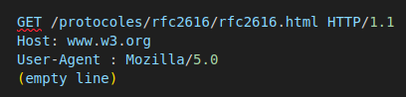

- The net/http library provides structures for HTTP messages

A) Request

- Represents an HTTP message request sent from the client/sent to the server
- The structure contains the parsed information that’s considered to be important & the number of usefull methods
- Important part of the Request are : URL/Header/Body/Form, Post-Form, MultpartForm
- We can also get access to the cookies/referring URL/user agent from methods in Request

1) Request URL
- URL field of a Request : representation of the URL sent as part of the request line (1st line of the HTTP Request)
- URL field : a pointer to the url.URL type (struct with a number of fields)
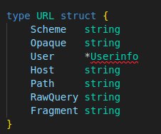

- The general for is : scheme://[userinfo@]host/path[?query][#fragment]
- URLs that dont start with a slash after the scheme as interpreted as : scheme:opaque[?query][#fragment]
- Programming webApps : we often pass informations from the client to the server using the URL Query
→ RawQuery field : provides the actual query string that’s passed through
→ Request sent to the URL http://www.example.com/post?id=123&thread_id=456
→ RawQuery’ll contain id=123&thread_id=456 & we’ll need to parse it to het the key-value pair
- There’s a convenient way to get the key-value pair : the Form field of a Request
- We can’t extract the fragment field out of a URL struct if we’re getting a request from the browser
→ fragments are stripped by the browser before being sent to the server (they never get sent to the server)
→ Not all requests come from browsers : we can get requests from HTTP client libraries/client frameworks (Angular)
→ Request isn’t used only at the server : can be used as a part of the client library

2) Request Header
- Map representing the key-value pairs in an HTTP header : there are 4 basic methods on Header
→ Add/delete/get/set values given a key
→ key : string and value : slices of strings
→ Setting a key creates a blank slice of strings as the value (1st element being the new header value)
- To add a new hedaer value to a given key : we append the new element to the existing slice of string
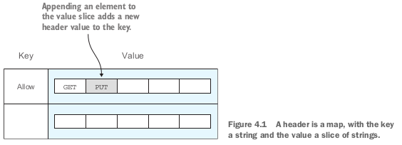

- Reading headers from a request
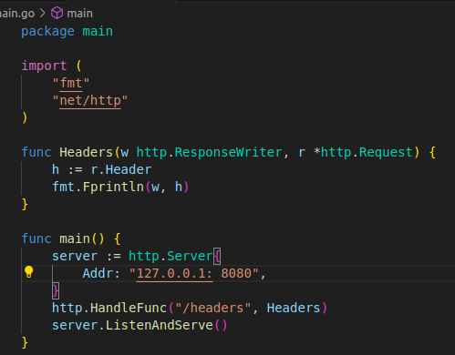

- what we get in the browser when we go to http://localhost:8080/headers
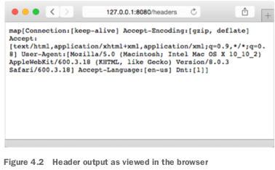

- To get just one particular header instead of using h:= r.Header we’d use h:= r.Header[« accept-encoding »]
→ we’d get [gzip, deflate]
- We can also use h:= r.Header.get(« accept-encoding ») we’d get gzip, deflate
- if we refer to the Header directly we’ll get a map of strings
- If we use the Get method on the Header we’ll get the the comma-delimited list of values (actual string of the header)

3) Request body
- Body field : io.ReadCloser interface
→ reader+closer interface
- Reader : interface that has a Read method that takes in a slice of bytes
→ Returns the number of bytes and an optional error
- Closer : interface that has a Close method that takes in nothing and returns an optional error
- We can call on the Read and Close methods of the Body field
- To read the content of a request body we can call the Body field’s Read method
- Reading data from a request body
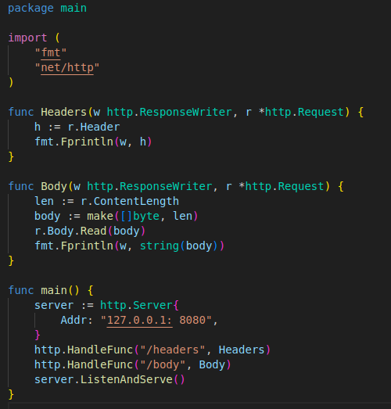

- We first need to determine how much to read by creating a byte array of the content length and call the Read method to read it
- To test it we need to send a POST request to the server with the appropriate message body (GET requests dont have a message bodies)
- We are able to send POST requests through a browser (we need an HTTP client)
→ We can use a desktop graphical HTTP client/a browser plug-in, extension/cURL from command line
- cURL : $ curl -id "first_name=sausheong&last_name=chang" 127.0.0.1:8080/body
→ I don’t get any response but we should get this in the console
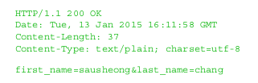

- Normally we wouldn’t need to read the raw form of the body : go provides methods such as FormValue/FormFile
→ To extract the values from a POST form

B) HTML forms

- Most often POST requests come in a form (pun intended : voulu) of an HTML form
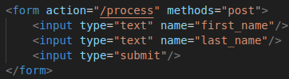

- Within the <form> tag : HTML form elements
→ text input/text area/radio buttons/checkboxes/file uploads
→ Allow the user to enter data to be submitted to the server
→ Data is submitted when the user clicks a button/triggers the form submission
- Data is sent to the server through an HTTP POST request & is placed in the body of the request
- HTML form data’s always sent as name-value pairs through a POST request
→ defined using the enctype attribute
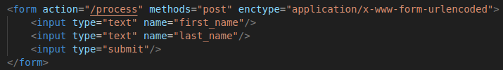
- The default value of enctype is application/x-www-form-urlencoded
→ Browsers are required to support at least pplication/x-www-form-urlencoded and multipart/form-data
→ HTML5 also supports text/plain value
- If we set enctype to application/x-www-form-urlencoded the browser’ll encode in the HTML form data a long query string with the name -value pair separated by & and the name separated from the values by =
→ The HTTP body’ll look like this
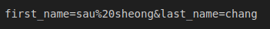

- If we set enctype to multipart/form-data each name-value pair’ll be converted into a MIME message part, each with its own content type and content disposition
- Our form data’ll look like something like this
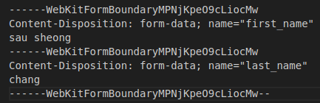

- If sending simple text data : URL encoded form is better (simpler/more efficient : less processing is needed)
- If sending large amoutns of data : multipart-MIME form is better (we can even specify that we want Base64 encoding to send binary data as text)
- HTML allows the method attribute to be either POST or GET
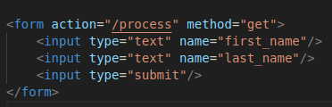

- In this case there’s no request body (GET requests have no request body)
→ All the data is set in the URL as name-value pairs

1) Form
- Functions in Request that allow us to extract data from the URL and/or the body
→ Form/PostForm/MultipartForm fields
→ The data is int he form of a key-value pairs
- The general algorithm is
→ Call ParseForm or ParseMultipartForm to parse the request
→ Access the Form, PostForm, MultipartForm field accordingly
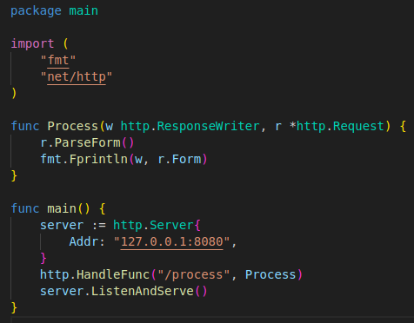

- The focus of the server is on these 2 lines :
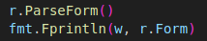

→ First parse the request using ParseForm
→ Then access the Form field
- client.html is the file’ll create to look at the client that’s going to call this server
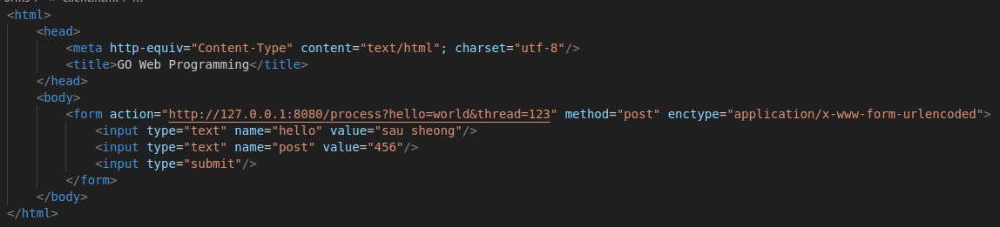
- In this form we are
→ Sending the URL http://localhost:8080/process?hello=world&thread=123 to the server using the POST method
→ Specifying the content type (in thr enctype field) to application/x-www-form-urlencoded
→ Sending 2 HTML form key-value pairs hello=sau sheong and psot=456 to the server
- We have 2 values for the key hello
→ world int the URL
→ sau sheong in the HTML form
- Open the client.html file dicrectly in your browser (don’t need to serve it up from a webServer)
→ Click the submit button
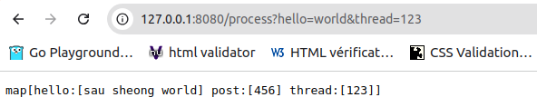

- This is the raw string version of the Form struc in the POST request after being parsed
- The form struct is a map : the key is a string and the value is a slice of strings
→ the map isn’t sorted : we could get a different sorting of the returned values (that we currently have)
→ hello=world & thread=123 or hello=sau sheong & post=456

2) PostForm
- If we only want the value to the key post we can use r.Form[« post »]
→Will give us a map with one element [456]
- If the form and the URL have the same key : both of them’ll be placed in a slice with the form value always prioritized before the URL value
- If we only need the form key-value pairs and want to totally ignore the URL key-value pairs
→ PostForm field that provides the key-value pair only for the form and not the URL
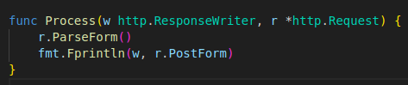

- Then we get that
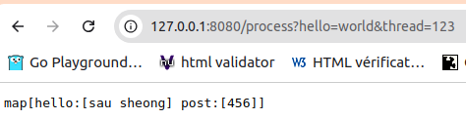

- What happens if we use multipart/form-data instead of application/x-www-form-urlencoded for the content type ?
→ We switch back to using r.Form
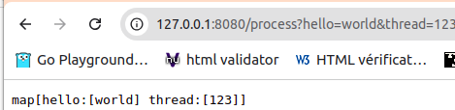

- We’re only supposed to get map[hello:world thread:[123]]
→ We’re only supposed to get the URL query key-value pairs and not the form key-value pairs
→ PostForm field only supports application/x-www-form-urlencoded
→ To get multipart key-value pairs from the body we must use MultipartForm field

3) MultipartForm
- Instead of using the ParseForm method on the Request struct and then using the Form field on the request
→ We have to use the ParseMultipartForm method (ParseForm method) when necessary
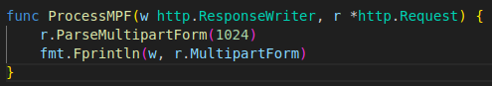

- We get this in the browser
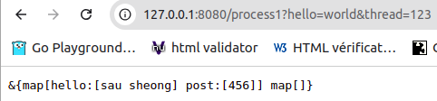

- This time we see the form key-value pairs but not the URL key-value pairs
→ Because the MultipartForm field contains only the form key-value pairs
- The returned value is no longer a map but a struct that contains 2 maps
→ First map : keys are strings/values are slices of string
→ Second map is empty because keys are strings but values are files
- The FormValue method is the easiest way to acces the key-value pairs
→ It’s for a specific key and we don’t need to call the ParseForm/ParseMultipartForm beforehand
→ The FormValue does that for us
- If we set the client’s form enctype to application/x-www-form-urlencoded and change our handler func
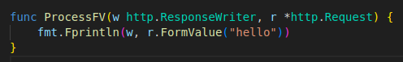

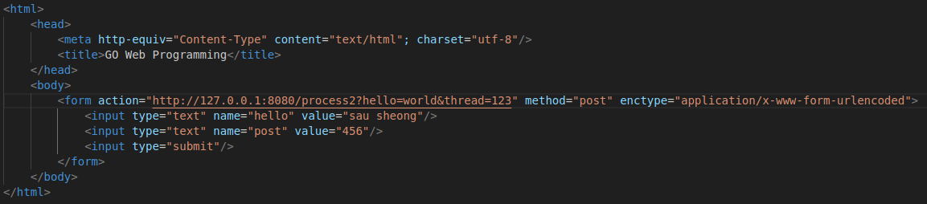
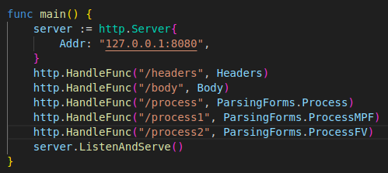

- Then we get this
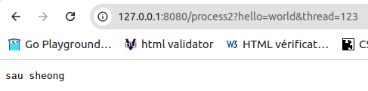

- The FormValue method retrieves only the first value even if we have multiple values in the Form struct
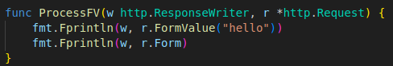

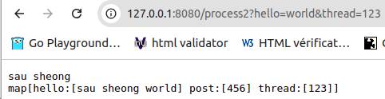

- The PostFormValue method does the same thing for the PostForm field
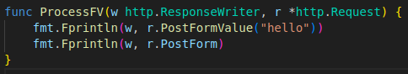

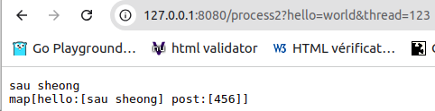

→ We only get the form key-value pairs
- Both FormValue & PostFormValue methods call the ParseMultipartForm method (we dont need to call it ourselves)
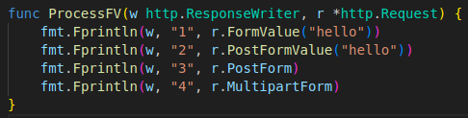

- In the document it said that the FormValue & the PostFormValue methods correspond to the Form and PostForm fields and not the MultipartForm field
→ the 2cd and 3rd lines are supposed to be empty because if we just take the form key-value pairs we get nothing
→ I asked my friend chatGPT and it seems that ParseMultipartForm is implicitely called by FormValue & PostFormValue : the form data is correctly parsed/stored in PostForm & MultipartForm
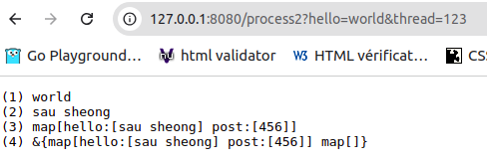

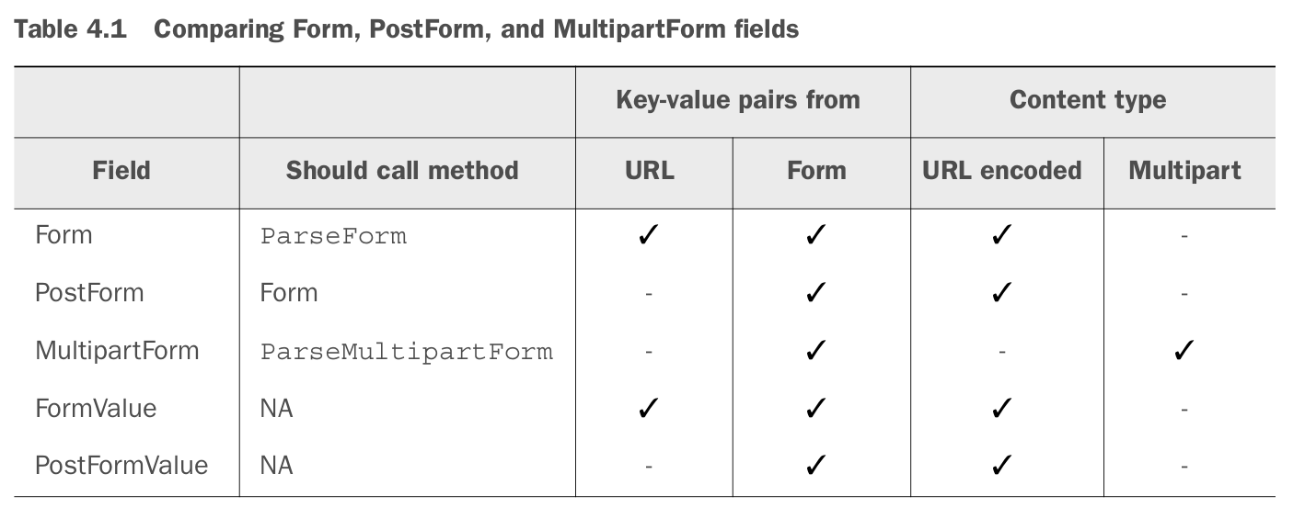
4) Files
- The most common use for multipart/form-data is uploading files (mostly the file HTLM tag)
a) Uploading files
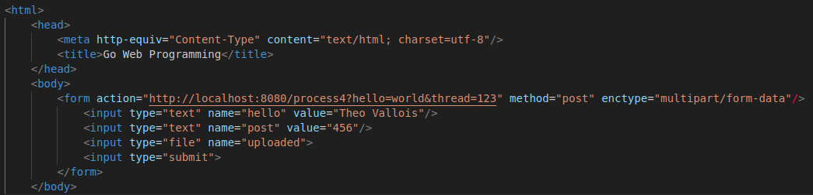

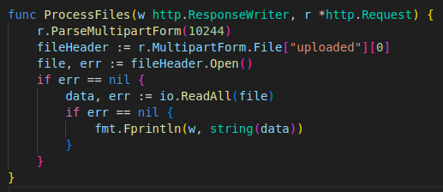

- We need to call the ParseMultipartForm method first
- Then we get a FileHeader from the File field and call its Open method to get the file
- If we upload a text file and send it accross the server
→ The handler’ll get the file, read it into a byte array and print it in the browser
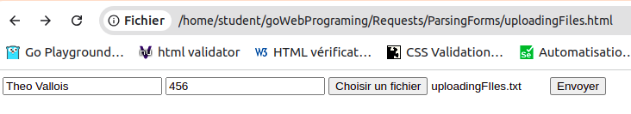

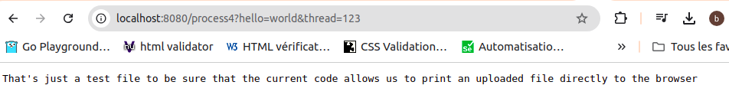

b) Retrieving uploaded files using the FormFile
- It’s the shorter way to get an uploaded file
- The FormFile method returns the first value given the key : fatser if we only have 1 file to be uploaded
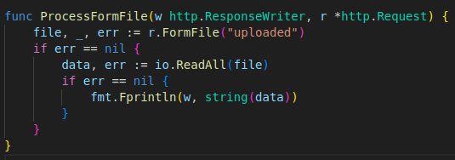

- We no longer have to call the ParseMultipartForm method as the FormFile method calls the file & the file header
→ We get the same result
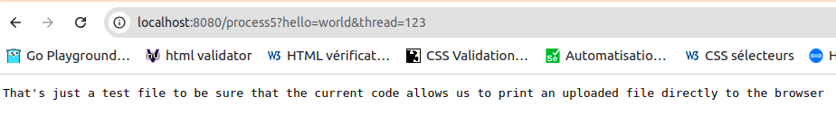

5) Processing POST requests with JSON body
- Sending POST requests is common with client libraries (JQUERY, Angular, Ember…)
- If we’re trying to get the JSON data from a POST request sent by an Angular client and use ParseForm method
→ We won’t be able to BUT JS libraries like JQUERY allow us to do so, why ?
- Client frameworks encode their POST requests differently
→ JQUERY encodes them like an HTML form (sets the request header Content-Type to application/x-www-form-urlencoded)
→ Angular encodes them with application/json (Go ParseForm method only parses forms : doesnt accept application/json)

C) ResponseWriter

- Sending a response to the client isn’t creating a Response struct, setting up the data in it and sending it out
→ The correct interface when sending a response from the server to the client is ResponseWriter
- ResponseWriter is an interface that the handler uses to create an HTTP response
→ The actual struct backing up ResponseWriter is the nonexported struct http.response
→ Because it’s nonexported we can’t use it directly but only through the ResponseWriter interface
- Why do we pass ResponseWriter into the ServeHTTP by value ? Why does the serveHTTP function takes 2 parameters (the ResponseWriter interface & a pointer to a Request struct) ?
→ Changes to request by the handler need to be visible to the server (so we pass it by reference instead of by value)
→ Why are we passing a ResponseWriter by value ? The server needs to know the changes to ResponseWriter too doesn’t it ?
→ Both parameters are passed in by reference : the method signature takes a ResponseWriter that’s an interface to a pointer struct so it looks as if it’s passed in by value
- The ResponseWriter interface has 3 methods : Write, WriteHeader & Header

1) Writing to the ResponseWriter
- The Write method takes in an array of bytes that gets written into the body of the HTTP response
- If the header doesn’t have a content type by the time Write is called
→ The first 512 bytes of the data are used to detect the content type
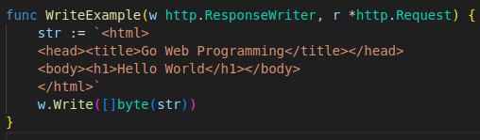

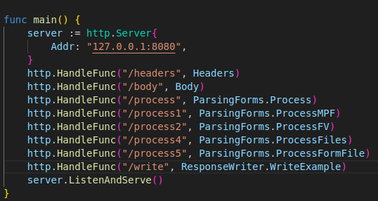

- We’re writing an HTML string to the HTTP response body using ResponseWriter
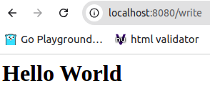

2) Writing headers to response using WriteHeader
- It doesn’t allow us to write any header (we use header for that)
- It takes an integer that represents the status code of the HTTP response and writes it as the return status code for the HTTP response
→ After calling this method we can still write to the ResponseWriter but we can no longer write to the header
→ If we don’t call this method : when calling the Write method by default the response code’ll be 200 OK
- The WriteHeader method is useful if we want to return error codes
→ Let’s say we’re writing an API and we defined the interface but haven’t fleshed it out
→ We want to return a 501 Not Implemented status code
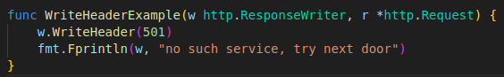

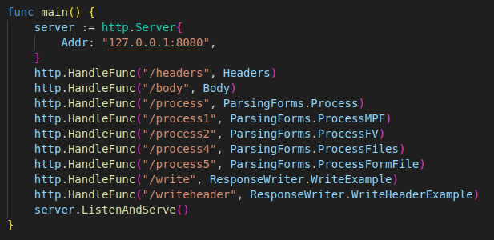

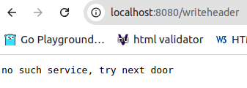

3) Writing headers to redirect the client
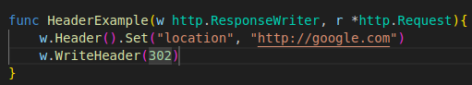

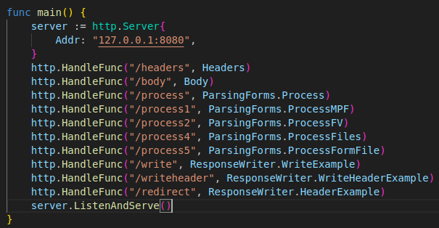

- It shows how a redirect works : it’s simple to set the status code to 302 and then add a header named Location with the value of the location we want the user to be redirected to
→ We must add the location header before writing the status code because the WriteHeader prevents the header from being modified after it’s called
→ When we call the URL from the browser we’ll be redirected to google

4) Writing JSON output
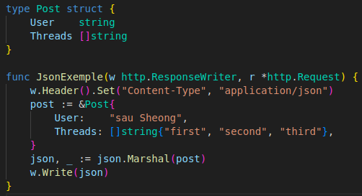

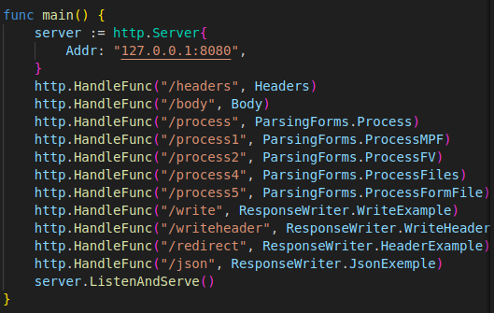

- First we set the content type to application/json using Header
- Then we write the JSON string to the ResponseWriter
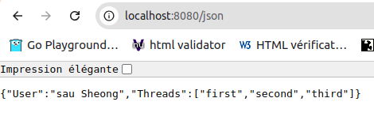

D) Cookies

- A cookie is a small peace of information stored at the client originally sent from the server through an HTTP response message
→ To create sessions for authentication
→ For persistence at the client in general
- Every time the client sends a HTTP request to the server, the cookie is sent along with it
- Cookies are made to overcome the stateless-ness of HTTP
→ Entire industrie’s revenues depend on it (internet advertising domain)
- There is a number of types of cookies : super cookies/third-party cookies/zombiz cookies
- Generally there are only 2 classes of cookies : session cookies and persistent cookies
→ Most other cookies are variants of the persistent cookies

1) Cookies with GO
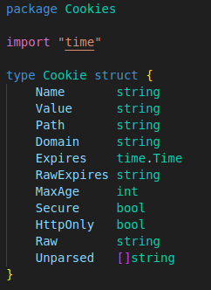

- If the Expires field isn’t set the cookie is a session or temporary cookie
- Session cookies are removed from the browser when it closes
→ Otherwise it’s a persistent cookie that lasts as long as it isn’t expired/removed
- 2 ways of specifying the expiry time : Expires/MaxAge fields
→ Expires : tells us exactly when the cookie’ll expire
→ MaxAge : tells us how long the cookie should last (in seconds) starting from the time it’s created in the browser

a) Sending cookies to the Browser
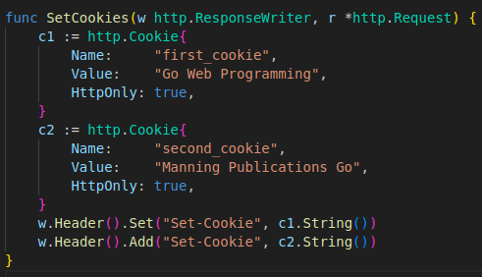

- Cookie has a String method that returns a serialized version of the cookie for use in the Set-Cookie response header
- We use the Set method to add the first cookie then the Add method to ad a second one
- Go to http://127.0.0.1:8080/set_cookie and then inspect the list of cookies set on the browser
- Go provides a simpler shortcut to setting the cookie : SetCookie func from the net/http library

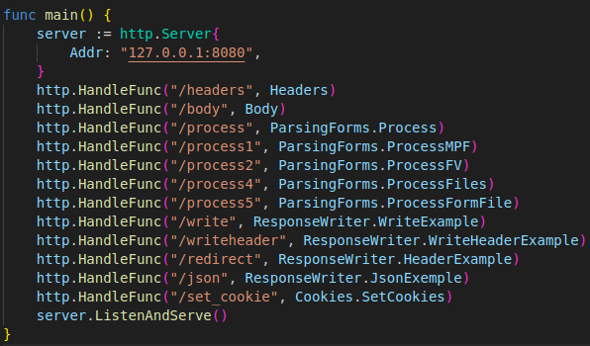

- To view the cookies we use the Web inspector
- On GoogleChrome we go the application, cookies, http://localhost:8080
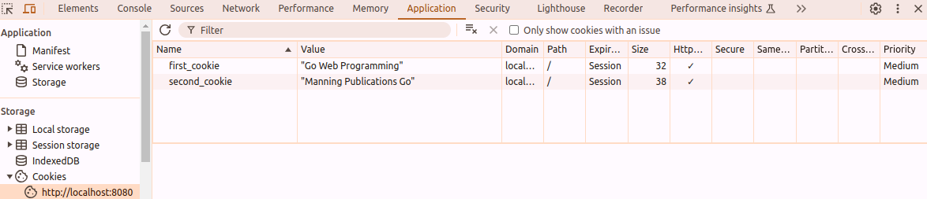

b) Sending cookies to the browser using SetCookie
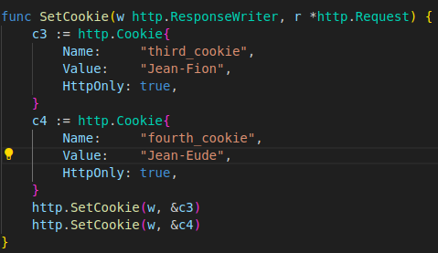

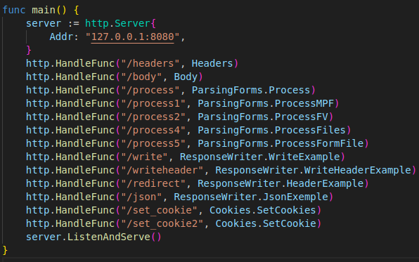

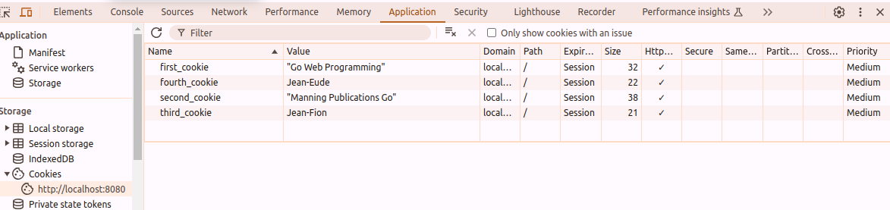

2) Getting cookies from the browser
- We saw how to set a cookie now we’ll se how to retrieve that cookie from the browser
a) Getting cookies from the header
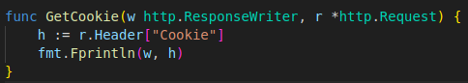

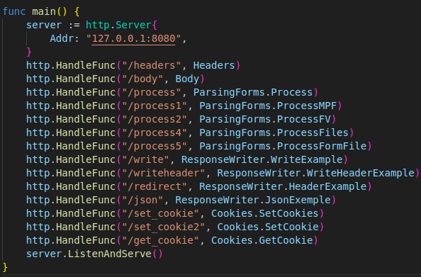

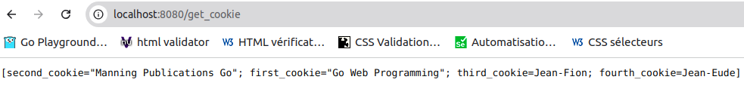
- This is a slice with a single string
- To get individual name value pairs we’ll have to parse the string ourselves
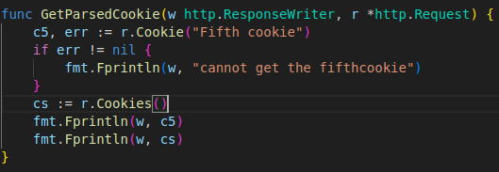

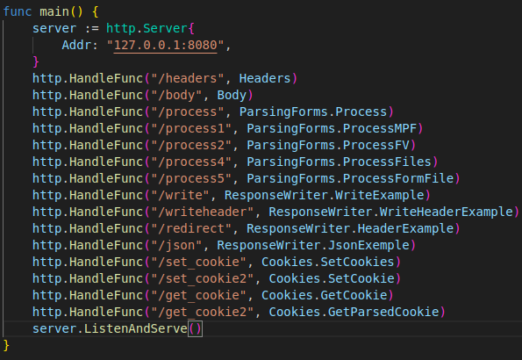

- Go provides a Cookie method on Request : allows us to retrieve a named cookie
- If the cookie doesn’t exist : error
- This is a single value : if we want to get multiple cookies we can use the Cookies method Request
→ We retrieve all the cookies into a Go slice : it’s the same than getting it through the Header ourselves
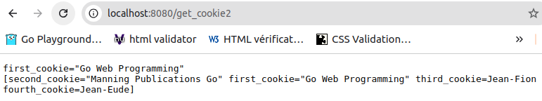

- We didn’t set the Expire/MaxAge fields : what returned are cession cookies
- If we quit the browser and open it again then go to http://127.0.0.1:8080/get_cookie
→ The cookies are gone

3) Using cookies for flash messages
- Sometimes it’s necessary to show users a short informationnal message telling them if they successfully completed an action
→ If the user submits a post to a forum and it fails he’ll want to know it
→ Following the Principal of Least Surprise we want to display the message on the same page
→This page doesn’t normally show any messages : the message must show on certain conditions and must be transient (doesn’t show again once the page is refreshed)
→ Transient messages : flash messages which can be implemented in several ways
→ The most common way is to store them in cession cookies that are removed once the page is refreshed
- We create 2 handler func : SetMessage/ShowMessage
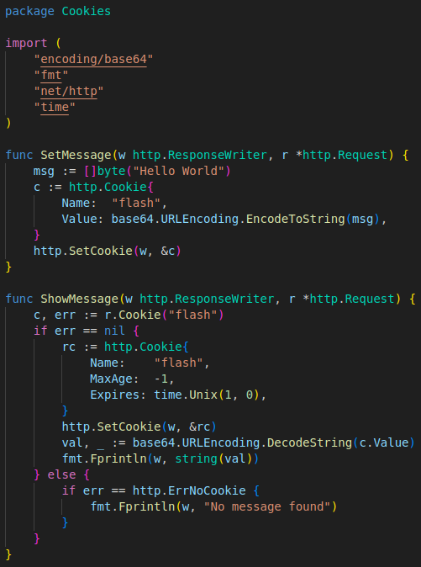

- SetMessage : not that different from the SetCookie handler func exepted thar we do a Base64.URL encoding of the message
→ The cookie values need to be URL encoded in the header
→ In this case it’s easy because we don’t have any special characters (space/%…)
- ShowMessage :
→ We get the cookie, if we can’t find it : err’ll have the value of http.ErerNoCookie « No message found » ‘ll display
→ We’ll have teo create a cookie with the same name but with MaxAge set to a negative number and an Expires value that’s in the past
→ Then send the cookie to the browser with SetCookie
- We’re replacing/removing the existing cookie because MaxAge is negative and Expires is in the past
→ Once we do that we can decode our string and show the value
- When we use the Web Inspector to look at the cookies at http://localhost:8080/set_message we get that :
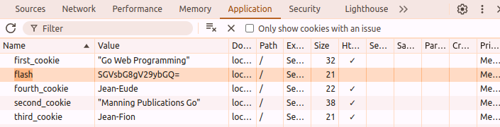

→ The value is Base64.URL encoded
- Now when we got to http://localhost:8080/show_message :
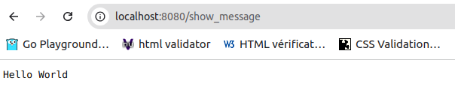

- When we inspect the page again for cookies we can see that the flash cookies are gone

SUMMARY

- Go provides a representation of the HTTP requests through various structs that can be used to extract data from requests
- Go Request struct has 3 fields : Form/PostForm/MultipartForm that allow easy extraction of different data from a request
→ To get data from these fields we call ParseForm/ParseMultipartForm to parse the request then access the Form/PostForm/MultipartForm field accordingly
→ Form is used for the URL-encoded data from the HTML form only
→ MultipartForm is used for multi-part data from the URL and HTML form
- To send data back to the client : write header and body data to ResponseWriter
- To persist data at the client : send cookies in the ResponseWriter
- Cookies can be used for implementing flash messages

